Advent 2

WALSINGHAM

Be like Jesus. Be your best. Be safe. Be caring.

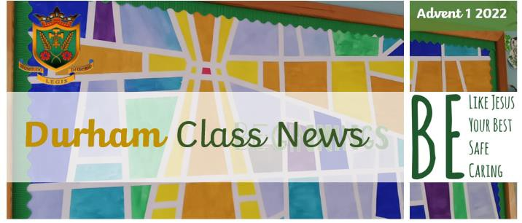

**Welcome Back**

Welcome back! We hope that you have had a wonderful break and that you’re ready for some exciting and challenging learning in Year Three!

**R.E.**

We are beginning our second topic ‘Promises’, in which we will be learning about the promises made at a

Baptism.

On Thursday 7th November, Year 3 will be leading the Celebration of the Word, about our class value Respect. Parents are welcome to attend.

This half term, all the classes in school will be learning about an aspect of the Jewish faith. In Year 3, we will be learning about the synagogue and its importance.

From mid-November until the end of term, we

will be learning about Advent and Christmas. Our topic is called ‘Visitors’. We will be learning about how we prepare for the coming of Jesus at Christmas, retelling the Nativity story through our writing and drama skills!

Prayer and worship remain an integral part of each day

and the children are very welcome to bring in and share

any prayers or books on our class prayer table.

**English**

**Writing:** In our Talk 4 Writing lessons this term, we will be writing our own action tale, based on ‘Chadwick and

the Sea Serpent’. To add depth to our writing, we will be learning how to use similes and metaphors to inject action into the setting, useing -ing words to drop the reader straight into the action and using fronted adverbials to create dramatic sentence starters to advance the action!

**Reading:** Firstly, thank you for your continued support with the children’s reading across the years – it is greatly appreciated! In Year 3, children are expected to

read at home for a minimum of 10-15 minutes a day every day – the more the better!

**Maths**

In Maths this half term, we will continue with our focus on addition and subtraction. This is followed by a focus on multiplication and division – 3, 4, and 8 times tables. Practice on Times Tables Rockstars will help with this greatly!

On Monday afternoons at 12.40, in the Y3 classroom, all KS2 children are welcome to join Maths club to practice their times tables.

**P.E.**

The children will have two P.E. lessons each week. This half term, our PE days will be **Mondays** and **Fridays.** As previously, children are to come to school in their active uniform. Outdoor kit should include plain black tracksuit bottoms, yellow polo shirt, yellow sweatshirtand outdoor trainers. Please ensure all items are fully labelled. We politely ask that long hair be tied back, and earrings removed on P.E. days. Whilst we advise against it, if your child’s earrings are new and unable to be taken out, they must be taped over with surgical tape, brought in from home.

**Foundation Subjects**

To see a breakdown of our foundation subjects (History, Geography, Art, D&T, RSE, Spanish & Computing) please see the curriculum overview on our class webpage.

**Homework**

As the children enter Upper Key Stage 2, we promote responsibility for learning through weekly homework. Homework is usually set on a Friday, due to be returned or completed the following Friday. If the children do not complete or return their homework, I will provide time (outside of lessons) for them to complete the work with me. They are more than welcome to ask you for support with their homework if needed, but if substantial support was needed, please make note of this on the sheet so that I am aware of this upon return. Alternatively, overarching homework projects may be set. These will span over a few weeks/a half term and details of each project will be sent home in plenty of time.

**Uniform**

After the October half term, all children must come to

school in their winter uniform. Details of this can be

found in our uniform policy, which can be accessed on

the school website.

We have a significant number of items in our cloakroom

that have been lost/left behind. Unfortunately, we cannot

return these to their rightful owners as they are not

labelled with children’s names. Please ensure that every

item of clothing clearly contains your child’s name so

that we can return anything that goes missing to them.

**Twitter**

As a reminder, our class Twitter page is @stlizclass21. I recommend following this page to be kept up to date with all things Year 3. Think of it as a virtual noticeboard!

**Water Bottles**

Children are asked to ensure they bring a water bottle to

school each day. They are encouraged to drink water

throughout the day to aid concentration. Water bottles

should be taken home each night for washing.

**Special Events**

**Thursday 7th November – Year 3 leading Celebration of the Word.**

**Friday 15th December – Last day to order Christmas dinner.**

**Tuesday 19th November – Feat day of St Elizabeth.**

**Thursday 28th November – Non-School Uniform Day**

Please bring chocolate to donate to the school fayre.

**Friday 29th November – School INSET day**

**Wednesday 4th December – SEA Gift Sale**

Children will have the opportunity to purchase a gift.

**Thursday 5th December – SEA Christmas Disco!**

**Friday 6th December – Non-School Uniform Day**

Please bring a bottle to donate to the school fayre.

**Friday 8th December – School Disco**

6:00-7:30, children can bring money for a tuck shop.

**Friday 13th December – SEA Christmas Fayre**

**Tuesday 17th December –Christmas dinner**

**Wednesday 18th December – Christmas Jumper day (nn-school uniform) and Christmas Panto.**

**Thursday 19th December – Advent Mass**

10am. All welcome.

**Friday 20th December – Last day of term.**

Break up for Christmas holidays . Please come and join us for Carols Around the Tree at 2pm in the school hall

If you have any quick questions, please feel free to speak to me at the end of the school day, once all of the children have been dismissed. If, at that point, you feel you require a longer appointment, we can arrange a meeting via the school office (01773 822278).

Thank you in advance for your support.

**Miss Evans**