|  |  |
| --- | --- |
| **Key Vocabulary and Definitions** | |
| **calendar** | A tool used to mark the passing of time and organise days and events. |
| **feast day** | A day set aside by the Church family to celebrate an event in the life of Jesus, Mary his mother or a saint. |
| **journey** | A trip from one place to another, or from one time to another. |
| **liturgical** | The Church family’s celebration and remembrance of the journey of Jesus when he lived on earth, his death and Resurrection. |
| **Ordinary Time** | The parts of the Church’s year that are not included in Advent, Christmas, Lent or Easter. Green is used for Ordinary Time, the colour of sprouting seeds and everyday life to show that we continue to grow in God’s love. |
| **Our Lady** | Another name for Mary, the mother of Jesus. |
| **seasons** | The different parts of the year that are marked by special activity. |



**St Elizabeth’s Catholic Voluntary Academy**

“Be like Jesus. Be your best. Be safe. Be caring.”

**Journeys**

**Key Knowledge**

* The **Liturgical** Year is the Church’s **calendar** and is marked by special events and seasons.
* The **Liturgical** Year begins with the 1st Sunday of Advent and ends with the **feast** of Christ the King.
* The Church family **journeys** with Jesus through the major events of his life, death and resurrection.
* A **feast day** celebrates an event in the life of Jesus, Mary his mother or a saint.
* The **Liturgical** **Seasons** are: Advent, Christmastide, **Ordinary Time**, Lent and Holy Week, Eastertide, Pentecost and **Ordinary time**. Different colours are used for each **season**.
* In **Ordinary Time**, we listen to a 3-year cycle of Gospels and readings as we **journey** with Jesus on his mission.
* There are **feast days** set aside to remember Mary e.g. the Annunciation (25March) and Assumption (15August). The Church remembers Mary especially in May and October and encourages people to pray the Rosary. The Mysteries of the Rosary: joyful, sorrowful, mysteries of

light and the glorious.

* Through prayer, Christians become
* closer to God. Prayer leads to action.

Our Big Question

**Is life a journey?**

[](https://www.google.co.uk/url?sa=i&rct=j&q=&esrc=s&source=images&cd=&cad=rja&uact=8&ved=2ahUKEwiMvsnZkN_eAhWDx4UKHbvbARQQjRx6BAgBEAU&url=https://www.vectorstock.com/royalty-free-vector/man-head-silhouette-profile-icon-vector-10076572&psig=AOvVaw21Ra-yezHZGyBWHauQMGvQ&ust=1542671314547973)

**Scripture**

Psalm 84

Psalm 118: 19-20, 26-29

Psalm 122: 1-9

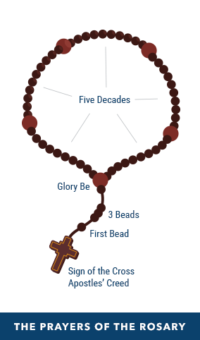[](https://www.google.co.uk/url?sa=i&rct=j&q=&esrc=s&source=images&cd=&cad=rja&uact=8&ved=2ahUKEwiMvsnZkN_eAhWDx4UKHbvbARQQjRx6BAgBEAU&url=https://www.vectorstock.com/royalty-free-vector/man-head-silhouette-profile-icon-vector-10076572&psig=AOvVaw21Ra-yezHZGyBWHauQMGvQ&ust=1542671314547973)

**Key Skills**

* I can accurately **retell** some of the stories of the Mysteries of the Rosary or special feasts. AT1 (i)
* I can **describe** the liturgical year and how it is composed of seasons and feast days. AT1 (ii)
* I can **describe** how prayer leads to actions. AT1 (iii)
* I can **share with and question** others about feelings and experiences of events that mark the year. AT2 (i)
* I can **question** others about things that cause me to **wonder** about how we help one another on the journey through the year. AT2 (ii)
* I can **express a point of view, make a link** to a source that could support a point of view and **begin to express a preference**. AT3

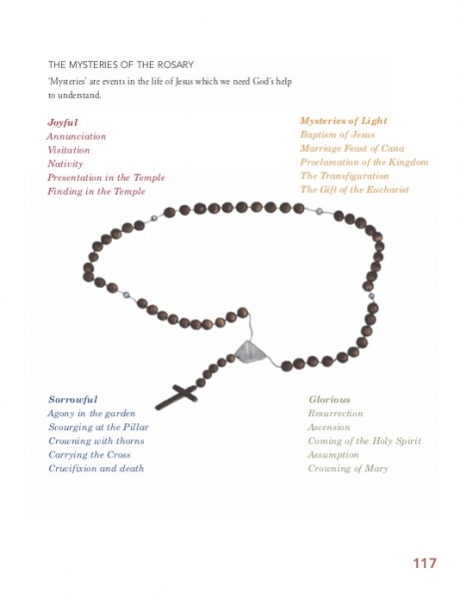

[](http://www.awesomehealth.nl/wp-content/uploads/2017/01/Hart.jpg)

[](https://www.google.co.uk/url?sa=i&rct=j&q=&esrc=s&source=images&cd=&cad=rja&uact=8&ved=2ahUKEwi905bjkd_eAhUICRoKHa-0BdEQjRx6BAgBEAU&url=https://thenounproject.com/term/thought-bubble/56884/&psig=AOvVaw3VPdHr6y4KQ2lJ2PnK3GL7&ust=1542671619436930)

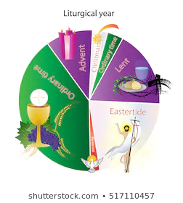

**We are in Ordinary Time**

The colour for Ordinary

Time is green. It is a

time when we

continue

to grow in

God’s love.



**Prior Knowledge and Skills**

* The parish family listens to God’s Word. The priest reads the Gospel, the stories of Jesus’ life. We stand to greet the Gospel.
* The four Gospels are: Matthew, Mark, Luke and John. They are in the New Testament. The Gospels tell the story of Jesus’ life on earth.
* We hear the story of Jesus’ Baptism after Christmas. Jesus is baptised in the River Jordan by his cousin John. John says he is not worthy. When Jesus is baptised, a voice from heaven said, “This is my Son.”
* Recognise the stories of the boy Jesus in the Temple, when on pilgrimage with Mary and Joseph.