|  |  |  |
| --- | --- | --- |
| **Year: Three** | **Subject: Geography** | **Topic: What Is Weathering?** |

******Saint Elizabeth’s Knowledge Mat**

1. **What I should already know:** To use basic geographical vocabulary to refer to: • key physical features, including: beach, coast, forest, hill, mountain, ocean, river, soil, valley, vegetation and weather.

To understand geographical similarities and differences through studying the human and physical geography of a small area of the United Kingdom and of a contrasting non-European country.

**4. Important vocabulary and facts:**

|  |  |
| --- | --- |
| SPELLING | DEFINITION |
| acidic | An acid is a chemical substance, usually a liquid, which reacts with other substances. Some acids burn or dissolve other substances that they come into contact with. |
| constantly | always |
| contributing | adding to |
| dissolve | to break down (usually in a liquid) |
| landforms | natural features of the Earth’s surface |
| pollution | adding something that has harmful effects |
| static | in one place (not moving) |
| temperature | the measured amount of heat in a place |

**5. Resources and skills to help me learn:**

Here are some videos that you may find helpful to watch: [What is Weathering? - Bing video](https://www.bing.com/videos/search?q=Weathering&docid=608029282274574413&mid=518ACB501C553FB8A0BF518ACB501C553FB8A0BF&view=detail&FORM=VIRE) [Mechanical and Chemical Weathering - Bing video](https://www.bing.com/videos/search?q=Weathering&ru=%2fvideos%2fsearch%3fq%3dWeathering%26qpvt%3dWeathering%26FORM%3dVDRE&qpvt=Weathering&view=detail&mid=40451B1E2724B904B61440451B1E2724B904B614&rvsmid=9AC91A198275A59B3F5E9AC91A198275A59B3F5E&FORM=VDRVRV)

**If it is safe to do so + with adult supervision, why not hunt for and photograph evidence of weathering in /around the locality?**

**3. Diagram / picture / quotation:**

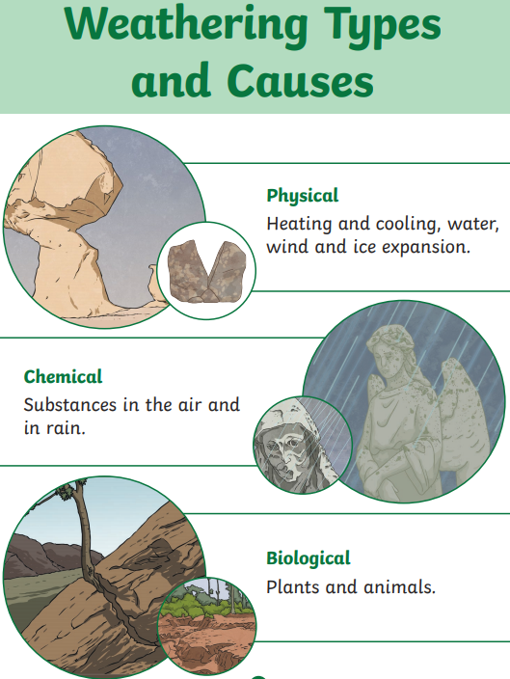

**2. What I am going to learn:**

**What is Weathering?**

The Earth's surface is constantly being broken down and reshaped. It is affected by many factors, most notably the weather, which includes wind, ice, rain and snow. Humans also can affect weathering by contributing to the pollution that may cause landforms to break down, like acid rain. Over time, this weathering can make huge changes to the landscape of the Earth.

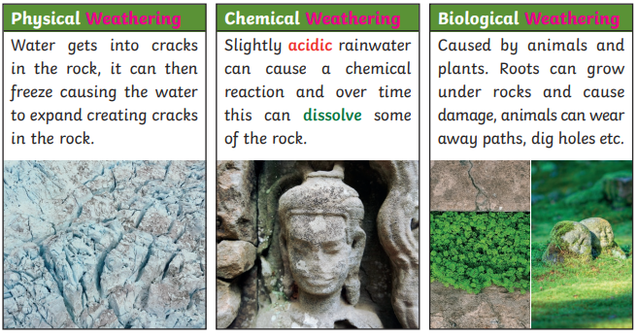

|  |  |  |
| --- | --- | --- |
| **My start and end of unit knowledge:**  **Name: _________________** | **Start of unit date: ___________**  **My answers at the START of the unit:** | **End of unit date: _________**  **My answers at the END of the unit:** |
| 1. **What does ‘weathering’ mean?** |  |  |
| 1. **Why is weathering ‘static’?** |  |  |
| 1. **How can water break down rocks?** |  |  |
| 1. [Weathering](http://en.wikipedia.org/wiki/Weathering)**How might this shape have been formed in the rock shown here?** |  |  |
| 1. **How can humans affect weathering?** |  |  |
| **Anything else I know about the topic:** |  |  |