**Chemistry**

What I already know:

* Rock is classified as a type of material.
* Rock can be used for building.

What I am going to learn:

* There are three types of rock: igneous, sedimentary and metamorphic.
* How they are formed and examples of each.
* Soil is the uppermost layer of the earth and is a mixture of minerals, air, water, and organic matter.

**St Elizabeth’s Knowledge Mat**

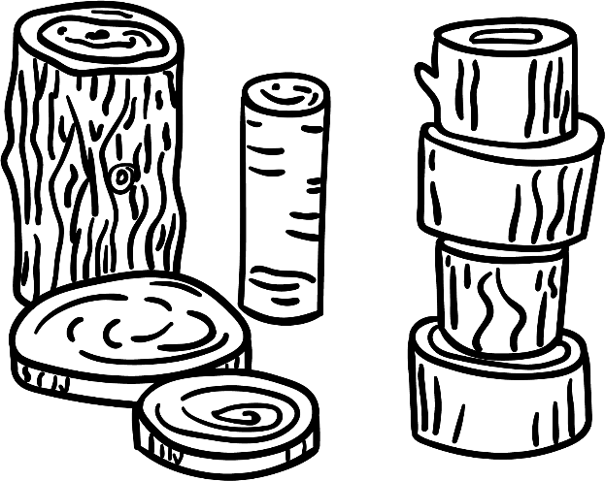

**Properties of Materials**

|  |  |  |
| --- | --- | --- |
| Year: Three | Subject: Science | Topic: Rocks and soil |

