|  |  |  |
| --- | --- | --- |
| **Year: Three** | **Subject: D&T** | **Topic: What does PNEUMATIC mean?** |

**Saint Elizabeth’s Knowledge Mat**

**2. What I am going to learn:**

What does pneumatic mean?

The word ‘pneumatics comes from the Greek word *‘pneumatikos’* where:

*pneu* = wind/gasses

*matikos* = power

Pneumatics is the science and technology of using air under pressure to transmit force and energy which will make things move.

We will learn that pneumatic systems can be used in combination with simple levers to control movement.

We will be making a ‘Moving Monster’.

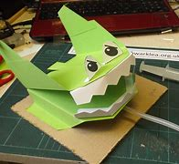

1. **What I should already know:**

This unit builds on Units [1A 'Moving pictures](https://webarchive.nationalarchives.gov.uk/20100512145851/http:/www.standards.dfes.gov.uk/schemes2/designtech/det3c/det1a)

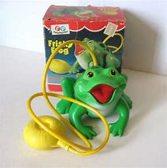

**3. Diagram / picture / quotation:**

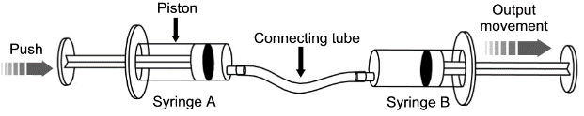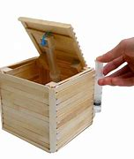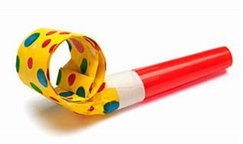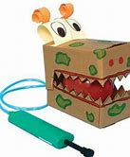

**4. Important vocabulary and facts:**

|  |  |
| --- | --- |
| SPELLING | DEFINITION |
| **air** | Air is the general name for the **mixture of gases that makes up the Earth's atmosphere.**  Air has no colour, taste, or odour. Although air is invisible, people can hear air when the wind howls. |
| **pneumatic** | using air under pressure to make things move |
| **pressure** | Pressure is a measure of how much force is acting on an area. |
| **syringe** | a tube with a nozzle and piston for sucking in and pushing our air or liquid |
| **tubing** | a length or lengths of metal, plastic, glass, etc., in tubular form. |

**Everyday things that use pneumatics.**

|  |  |  |
| --- | --- | --- |
| **Name: _________________** | **Start of unit date: ___________**  **My answers at the START of the unit:** | **End of unit date: _________**  **My answers at the END of the unit:** |
| 1. **How can you lift a book with a balloon?** |  |  |
| 1. **Can you name three or more things that use air to make them move?** |  |  |
| 1. **What does the word ‘pneumatic’ mean?** |  |  |
| 1. **Can you explain what this diagram is showing?**See the source image |  |  |
| **Anything else I know about the topic:** |  |  |