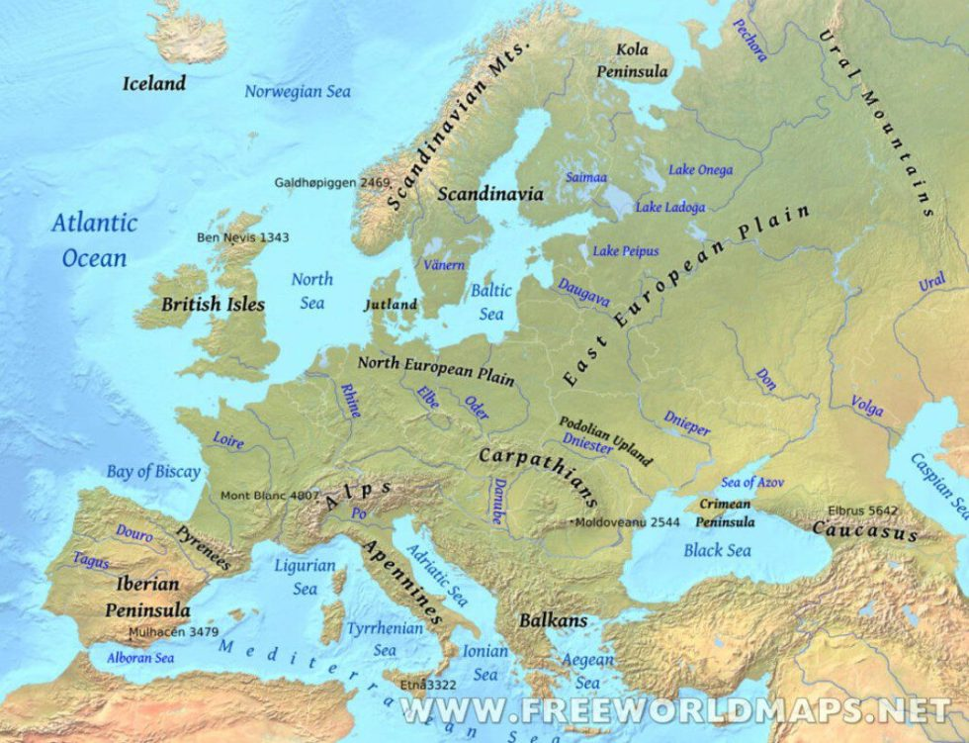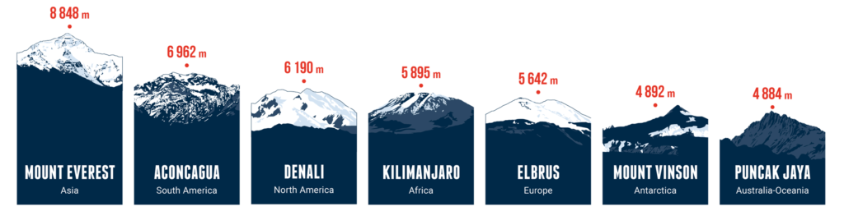

**St Elizabeth’s Knowledge Mat**

Key vocabulary

|  |  |
| --- | --- |
| **atlas** | A book of maps and charts. |
| **area** | The amount of space taken up by a 2D shape or surface. We measure area of counties in km² |
| **Capital city** | The most important city in the country and is where the government run the country from. |
| **Continent** | A large land mass. The world is split into seven different continents |
| **Country** | An area of land with its own government. |
| **Culture** | A group of people’s traditions and beliefs that they practice in their daily lives. |
| **Currency** | A system of money in general use in a country. |
| **Identity** | National identity is a person’s identity or sense of belonging to one state or to one nation. |
| **Landmark** | A building or place that is easily recognized, especially one that you can use to judge where you are: The Eiffel Tower is one of the most famous landmarks in Paris |
| **Population** | All the people who live in a place. |
| **Tourism** | People traveling for fun. It includes such activities as sightseeing and camping. Places that people go to for tourism are called tourist destinations. |

What I already know:

The **seven continents** and **five oceans** of the world.

Some features of **human** and **physical** geography.

Simple compass directions – **N, S, E** and **W**.

|  |  |  |
| --- | --- | --- |
| Year: Three | Subject: Geography | Topic: Europe |

What I am going to learn:

Europe is a continent made up of 50 countries and name some of these countries.

Name and locate 4 mountain ranges in Europe (Apennines, Carpathian, Alps, Pyrenees, Ural, Caucasus, Balkan, Scandinavian).

The highest mountain in Europe is Mount Elbrus in the Caucasus mountain range.