|  |  |  |
| --- | --- | --- |
| Year: Three | Subject: Geography | Topic: Describing maps of the world |

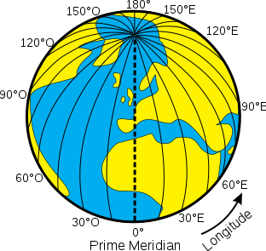

What I already know:

Where **North**, **South**, **East** and **West** are and that a **compass rose** shows this on a map.

A **sketch map** is a simple, roughly drawn map and that an **atlas** is a book of maps.

What I am going to learn:

Near to the **equator** are two imaginary lines called the **Tropic of Cancer** and the **Tropic of Capricorn**, and that places between the Tropics are known as **tropical**. They have a hot **climate** all year round.

Running from **North** to **South** is another imaginary line called the **Prime** **Meridian**. This splits the Earth into two more hemispheres: the **western** **hemisphere** and the **eastern** **hemisphere**.

**St Elizabeth’s Knowledge Mat**

Prime Meridian

Key vocabulary

|  |  |
| --- | --- |
| **Equator:** | An imaginary line drawn across the exact middle of the globe. |
| **Tropic of Cancer:** | 23.5 degrees north of the Equator. |
| **Tropic of Capricorn:** | 23.5 degrees south of the Equator. |
| **Tropical:** | Hot climate all year round. |
| **Prime Meridian:** | Imaginary line running from north or south of the globe. |
| **Hemispheres** | **:** (Northern/Southern and Eastern/Western): Halves |
| **Longitude:** | Imaginary lines measuring how far North or South a location is. |
| **Latitude:** | Imaginary lines measuring how far East or West a location is. |