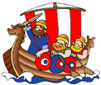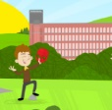**Saint Elizabeth’s Knowledge Mat**

**5. Resources and skills to help me learn:**

<https://www.powershow.com/view/205be8-NTNlZ/Antoni_Gaudi_powerpoint_ppt_presentation>

**Be creative and design your own fantastical buildings!**

Antoni Gaudi

Antoni Gaudi was a Spanish artist/ architect. He died in 1926

You will see his work especially in the city of Barcelona.

Four famous buildings designed by Antoni Gaudi are: Sagrada Familia, Park Güell, Casa Milà, Casa Batlló.

He used lots of curved lines and was inspired by natural forms.

The Sagrada Familia is due to be completed in 2026 a hundred years after Gaudi’s death.

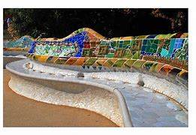

Gaudi

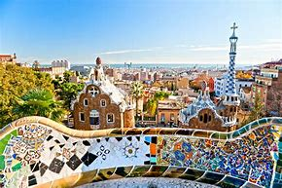 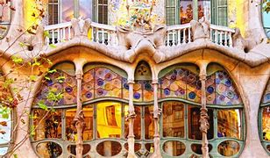

‘Nothing is invented, for it is written in nature first.’

Antoni Gaudi

**3. Diagram / picture / quotation:**

**4. Important vocabulary and facts:**

|  |  |
| --- | --- |
| SPELLING | DEFINITION |
| **architecture** | the art or practice of designing and constructing buildings. |
| **design** | a sketch, model, or plan of something made or to be made |
| **natural forms** | The natural form of an object which has not been altered but is in its' **original form** found in nature. |
| **mosaic** | a picture or pattern produced by arranging together small pieces of stone, tile, glass. |
| **fit for purpose** | An object that is appropriate for what it is intended to be used for.  A chocolate teapot is **no**t ‘fit for purpose’. |

**2. What I am going to learn continued:**

People love to sit on park benches all over the world.

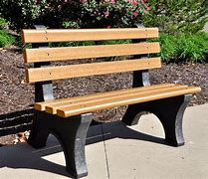

You will be inspired by the designs Antoni Gaudi and natural forms to design and model your own park bench.

Your design must be creative but at the same time be practical for people to sit on.

1. **What I should already know:**

Y2 -

To show pattern and texture in drawing.

To say how other artists have used colour, pattern and shape.

To mix paint to create all the secondary colours…

|  |  |  |
| --- | --- | --- |
| **Year: Three** | **Subject: ART** | **Topic: Who is Antoni Gaudi?** |