|  |  |
| --- | --- |
| **Key Vocabulary and Definitions** | |
| **home** | Where you live with your family. |
| **love** | When you really care about someone of something. |
| **family** | A group of people related to each other. |
| **difference** | When things are not like each other. |
| **respect** | Giving something honour or admiration. |
| **joys** | Times and feelings of great happiness. |
| **sorrows** | The feelings of sadness after something bad or upsetting has happened. |
| **community** | A group of people who live close together or who have shared interests. |

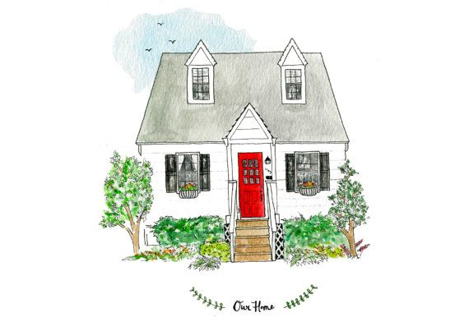

**St Elizabeth’s Catholic Voluntary Academy**

“Be like Jesus. Be your best. Be safe. Be caring.”

**Key Knowledge**

* God is present in every **home**. We know this because of the **love** that binds the **family** together through good times and bad times.
* In his letters, St Paul gives us advice about how to live as a family at home.
* We are all God’s children so we must try to be like Him.
* Mary, Joseph and Jesus give us an example of a happy and caring family.
* Prayer helps us remember that God is

always with us.

* Jesus wants us to love one another.
* We have been chosen by God to be a

holy people.

**Our Big Question**

**What makes a house a home?**

[](https://www.google.co.uk/url?sa=i&rct=j&q=&esrc=s&source=images&cd=&cad=rja&uact=8&ved=2ahUKEwiMvsnZkN_eAhWDx4UKHbvbARQQjRx6BAgBEAU&url=https://www.vectorstock.com/royalty-free-vector/man-head-silhouette-profile-icon-vector-10076572&psig=AOvVaw21Ra-yezHZGyBWHauQMGvQ&ust=1542671314547973)**Homes**

[](https://www.google.co.uk/url?sa=i&rct=j&q=&esrc=s&source=images&cd=&cad=rja&uact=8&ved=2ahUKEwiMvsnZkN_eAhWDx4UKHbvbARQQjRx6BAgBEAU&url=https://www.vectorstock.com/royalty-free-vector/man-head-silhouette-profile-icon-vector-10076572&psig=AOvVaw21Ra-yezHZGyBWHauQMGvQ&ust=1542671314547973)

**Key Skills**

* I can **retell** accurately all key elements of the advice offered by St Paul in his letters. AT1 (i)
* I can **describe** and give many appropriate examples of ways in which Christians live as people chosen by God. AT1 (iii)
* I can **share with** others my experiences of homes and how I have felt. AT2 (i)
* I can **speak to and question others about things that cause me to wonder** about what makes a house a home and how God is always with us. AT2 (ii)
* I can **begin to express a point of view** and **make a link** to a source that could support this. AT3

**Scripture**

Romans 12: 8-13 – *Be Real About Loving*

Ephesians 5: 1-9; 6: 1-4

Luke 2 39-40

John 13: 34-35 – *A New Rule*

Colossians 3: 12-17

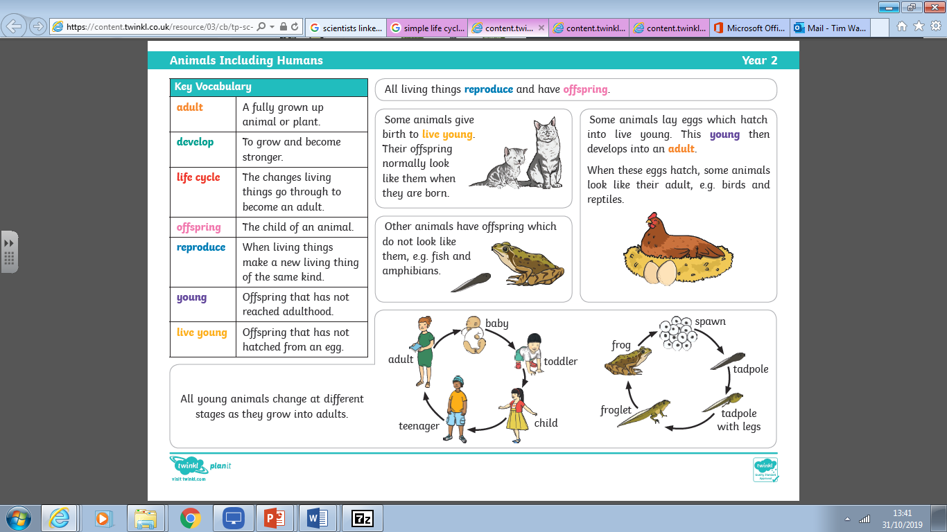

[](http://www.awesomehealth.nl/wp-content/uploads/2017/01/Hart.jpg)

**Other Sources**



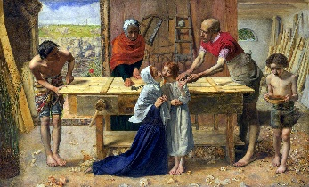

**Hymns**

* Family of God
* The Great Commandment by John Burland
* A New Commandment

[](https://www.google.co.uk/url?sa=i&rct=j&q=&esrc=s&source=images&cd=&cad=rja&uact=8&ved=2ahUKEwi905bjkd_eAhUICRoKHa-0BdEQjRx6BAgBEAU&url=https://thenounproject.com/term/thought-bubble/56884/&psig=AOvVaw3VPdHr6y4KQ2lJ2PnK3GL7&ust=1542671619436930)

Christ in the Carpenters’ Shop

by Millais

**We are in Ordinary Time**

The colour for Ordinary

Time is green. It is a

time when we continue

to grow in God’s love.

Through the Gospels,

we are journeying with

Jesus on his mission.

**Prior Knowledge and Skills**

* I have retold accurately many key elements from religious stories and some letters from St Paul (e.g. 1 Thes 4:13-14, 18; Col 3: 10-16; Eph 1: 4-5; Rom 8: 22-28)
* I have described and given many examples of how Christians live their life because of what they believe.
* I have asked and answered some questions about how my experiences of families.
* I have been able to ask somebody why they are wondering about something and say what I wonder about God and Jesus.
* I have been able to listen and respond to many points of view and ask and respond to questions about sources.

