Saint Elizabeth’s Knowledge Mat
Year: 4 | Subject: Science | Topic: Sound

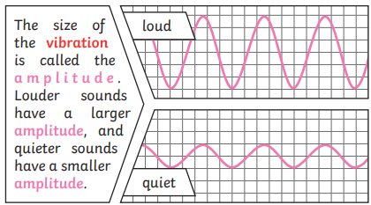

2. What I am going to learn –
My Sticky Knowledge

- Sound is created through vibrations which travel through a medium to the ear.
- Pitch and volume of a sound change when the vibrations or features of an object change.
- Pitch is a measure of how high or low a sound is.
- Sound can travel through solids, liquids and gases.
- Some materials absorb sounds.
- What I know already:
- EYFS – Changes, how things work
- Y3 – Skeletal and muscular system.
3. Key vocabulary
Ear | An organ used for hearing
Particles | Solids, liquids and gases are made of particles. They are so small we are unable to see them.
Soundproof | Prevents sound from passing through
Absorb sound | Absorbent materials have the effect of muffling sound,
Eardrum | A part of the ear which is a thin layer of tissue, stretched out like a drum skin. Soundwaves make the eardrum vibrate.
vibration | A movement backwards and forwards
Sound wave | The loudness of a sound
Amplitude | The size of a vibration. The larger the amplitude, the louder the sound.
Pitch | How high or low a sound is.

