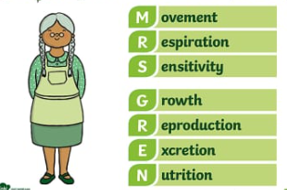 **Saint Elizabeth’s Knowledge Mat**

1. **What I know already:**

* EYFS – Things I notice in different environments
* Y2- Things can be classified as living, dead or never alive.
* Y2 –Habitats are where living things live and they provide a food source.
* Y2 - Plants need water, soil and sunlight to survive.
* Y3 –Living things need certain things in order to survive.
* Y4 – Food chains tell us about the food sources of various living things, and animals can be classified as carnivores, herbivores or omnivores based on their diets,.

|  |  |  |
| --- | --- | --- |
| **Year:** 4 | **Subject:** Science | **Topic:** Living Things and Their Habitats |

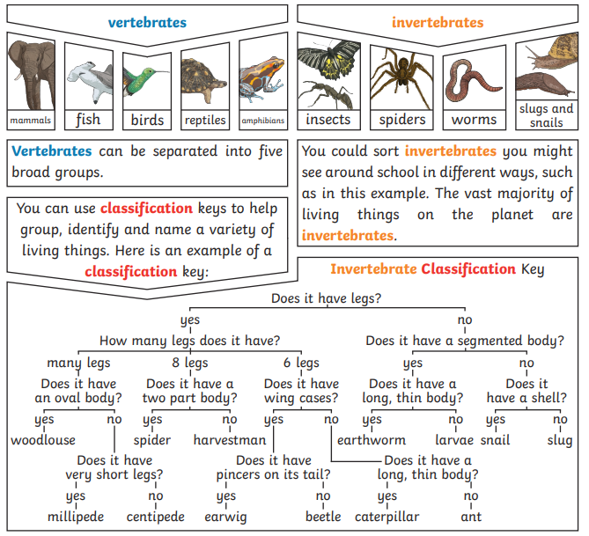

**2. What I am going to learn – My Sticky Knowledge**

* Living things can be classified in a variety of ways.
* Humans can have positive and negative impacts on habitats, locally and globally.
* Different changes occur in different habitats.
* Plants and animals adapt to their environment in order to survive.

**3. Key vocabulary**

|  |  |
| --- | --- |
| **Classification** | Where plants or animals are placed into groups according to their similarities. |
| **Vertebrates** | Animals with a backbone |
| **Invertebrates** | Animals without a backbone |
| **Characteristics** | Distinguishing features that are specific to a species. |
| **Organisms** | Another word for living things |
| **Endangered species** | A plant or animal where there are not many left and scientists are concerned that they may become extinct. |
| **Extinct** | When a species has no more members left alive. |
| **Habitat** | The specific area where a particular animal lives. |
| **Environment** | The environment contains many habitats |