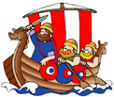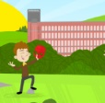**Saint Elizabeth’s Knowledge Mat**

**Who was Jedediah Strutt and how did he change Belper?**

Jedediah Strutt was born in 1726. In the early 1770’s he partnered Sir Richard Arkwright and Samuel Need in the construction of [Cromford mill](http://www.thepeakdistrict.info/fast/html/cromford_mill.html).

He built his first mill in Belper, the South Mill, in 1776, the North Mill in 1786, and then other mill buildings - eight in total.

It was his mills that transformed Belper and brought prosperity to the town which, before then, was more of a small village.

The Strutt family provided many local facilities including housing for their workers.

He was a religious man and cared for the welfare of his workers, he built the Unitarian Chapel so that children could attend Sunday School.

Jedediah’s sons, William, George and Joseph continued to be great benefactors of Belper, providing farms, allotments, parks, schools, hospitals, and much more.

**Should all old buildings be preserved?**

Today, the East Mill in Belper is in a poor state of repair, should it be allowed to become derelict? Could the building be used for other purposes? Do you think people would still visit Belper if there were no mill buildings?

1. **What I should already know:**

* Y1 **-** What was Belper like in the past? – About Herbert Strutt, Nailers and The North Mill
* Y2 - Why were the River Gardens built? - The history of Belper River Gardens.

Before 1770, Cromford was little more than a cluster of cottages around an old packhorse bridge and a chapel where travellers gave thanks for a safe journey. All that was soon to change with the arrival of one man, Richard Arkwright.

**Who was Sir Richard Arkwright and why was he so important?**

Richard Arkwright was born in 1732 in Preston.

He was originally a barber/wig maker in Bolton, however when the fashion for wigs declined, he looked to mechanical inventions in the field of textiles to make his fortune.

In 1767 devised the first water powered spinning frame, a machine which replaced the spinning that was done at home by many people’s fingers.

He was one of the key inventors and businessmen during the early stages of the Industrial Revolution.

His mill at Cromford was the first water powered cotton spinning mill in the world.

He established factories in Derbyshire, Staffordshire, Lancashire and Scotland, making him a wealthy man.

**2. What I am going to learn:**

**How the mills change the lives of people in our local area?**

**What was Belper like before 1770?**

Up until 1770, Belper was only a small village surrounded by fields with a population of just over 500 people (framework knitters and nail makers).

**What is a mill and what do you need to make one?**

You will need:

* Available land
* A source of power
* Raw materials
* A workforce
* Transport links

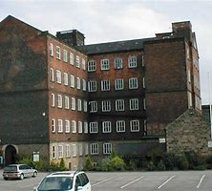 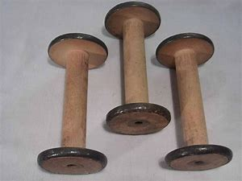

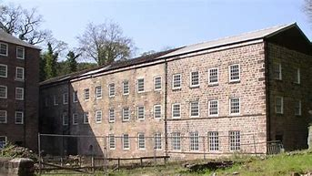 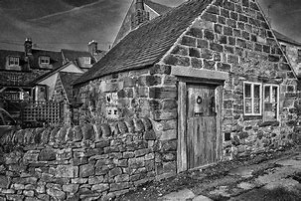 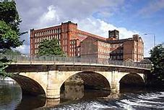 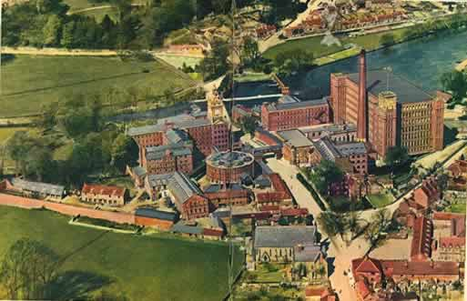

|  |  |  |
| --- | --- | --- |
| **Year: Three** | **Subject: HISTORY** | **Topic: Why is Local History Important?** |

**3. Important vocabulary and facts:**

|  |  |
| --- | --- |
| SPELLING | DEFINITION |
| **carding** | A process to disentangle, clean and straighten fibres of cotton. |
| **conservation** | To work to protect something for the future. |
| **construction** | To work to build something. |
| **cotton** | A soft white substance which surrounds the seeds of the cotton plant and is made into textile fibre and thread for sewing. |
| **demolish** | To pull something down and destroy it. |
| **Derby Rib** | The ‘Derby Rib’ machine, invented to allow the production of ribbed stockings. |
| **derelict** | A (building) or something that has abandoned and left to fall apart. |
| **employment** | Where a person is paid to work for another person. |
| **factory system** | The factory system **began during the Industrial Revolution**. The factory system used powered machinery, unskilled workers working in ‘shifts’ in one main building to make lots of the same products. |
| **heritage** | Things of special architectural, historical, or natural value that are preserved for the nation. |
| **hosiery** | The trade of making stockings was known as ‘hosiery’. |
| **indenture** | A legal document between the employer and worker. |
| **Industrial Revolution** | From 1760, the introduction of steam and water powered machinery meant that factories could make things much more quickly and cheaper than traditional hand made products. |
| **local** | **A person or thing belonging to a specific town or area.** |
| **machine** | An object that uses power to apply forces and control movement to perform an action. |
| **mill** | A mill is a building or group of buildings equipped with machinery for processing raw materials into a finished product. |
| **opinion** | Is when someone shares what they think about something. |
| **piecers** | Young children were employed as ‘piecers’ and had to lean over the spinning-machine to repair the broken threads. |
| **scavengers** | Young children were employed as ‘scavengers’ and had to crawl under the machines to sweep and collect loose cotton fibres. |
| **smelting** | The heating of metal ‘ore’ (rocks) to extract the metal e.g. iron. |
| **spinning** | Twisting/ twirling fibres into a continuous thread. |
| **transport** | To take or carry (people or goods) from one place to another by means of a vehicle. |
| **textile** | A type of cloth or woven fabric. |
| **Unitarian** | Unitarians base their religious beliefs on reason and experience. They believe that the God in Christianity is one person and not that God is one being in three persons: the Father, Son, and Holy Spirit. |
| **water course** | A channel through which water flows. |
| **water wheel** | A large wheel driven by flowing water, used to work machinery. |
| **weaving** | A method of interlocking threads to form a fabric or material. |
| **weir** | A dam in a stream or river to raise the water level or change the direction of its flow. |

**5. Resources and skills to help me learn:**

Have a go at building a model of a water wheel.

Can you find out more about Jedediah Strutt’s sons, William, George and Joseph Strutt and what they did? Make a presentation for the class.

If you could do something for the people of Belper, what would it be and why?

**3. Diagram / picture / quotation:**

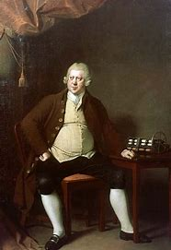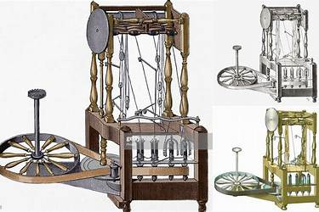

[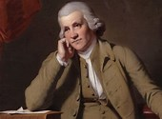](https://www.bing.com/images/search?q=image+of+jedediah+strutt&id=9DA5BCC0B8EC8279D68F4A63F98F50E3A5B143FA&FORM=IQFRBA)

**Stephen Gardiner:**

**The Industrial Revolution was another of those extraordinary jumps forward in the story of civilization.**

