**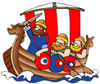****Saint Elizabeth’s Knowledge Mat**

**5. Resources and skills to help me learn:**

Why not visit Derby Museum and Art Gallery to be impressed by some of Joseph Wrights finest artworks.

[Museum & Art Gallery | Derby Museums](https://www.derbymuseums.org/museum-and-art-gallery/)

**4. Important vocabulary and facts:**

|  |  |
| --- | --- |
| SPELLING | DEFINITION |
| philosopher | a person who studies ideas about knowledge, right and wrong, reasoning, and the value of things |
| orrery | a clockwork model of the solar system, or of just the sun, earth, and moon. |
| enlightenment | the **state of having knowledge or understanding** |
| illuminated | to shine light on (something) |
| shading | the use of marking made within outlines to suggest three -dimensions, [shadow](https://www.merriam-webster.com/dictionary/shadow), or degrees of light and dark in a picture or drawing |
| **tenebrism** | In tenebrism paintings, the figures are often portrayed against a background of intense darkness, but the figures themselves are [illuminated](https://www.merriam-webster.com/dictionary/illuminated) by a bright, searching light that sets off their three-dimensional forms. |

**3. 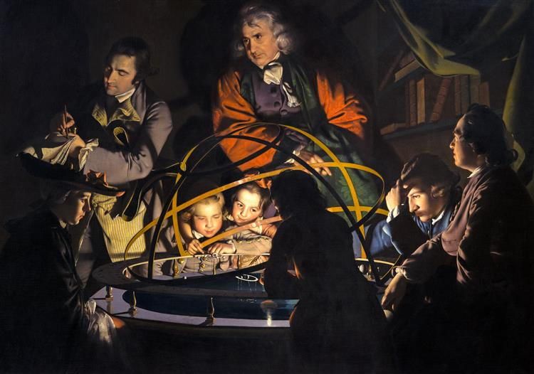Diagram / picture / quotation:**

**‘A Philosopher giving that Lecture on the Orrery in which a lamp is put in place of the Sun’. (1766)**

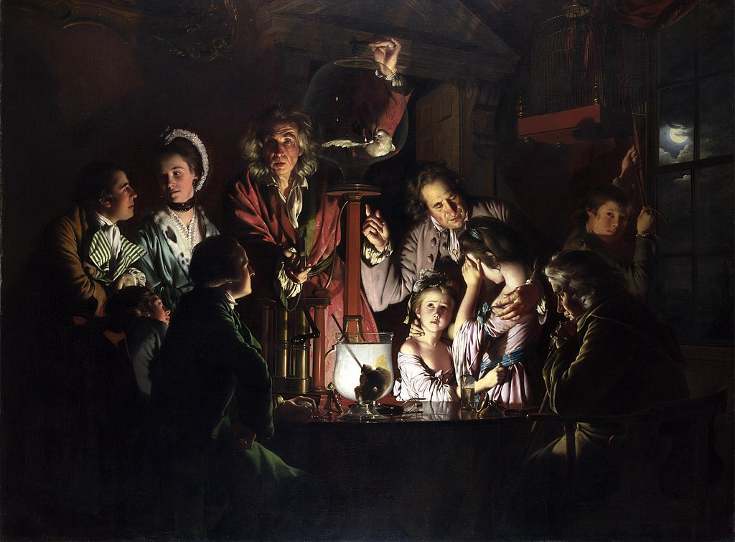

**An Experiment on a Bird in the Air Pump (1768)**

What questions would you ask Joseph Wright if you could?

How would you describe Joseph Wright’s style of painting?

**2. What I am going to learn:**

**What is Joseph Wright famous for painting?**

Joseph Wright (1734 –1797), was an English landscape and portrait painter. He has been acclaimed as "the first professional painter to express the spirit of the [Industrial Revolution](https://en.wikipedia.org/wiki/Industrial_Revolution)".

**How did Joseph Wright use light in his work?**

Wright is notable for his use of [tenebrism](https://en.wikipedia.org/wiki/Tenebrism) effect, which emphasizes the contrast of light and dark, and, for his paintings of candle-lit subjects.

Joseph Wright wanted to share the developments in science and greater understanding/ wonder of how the world worked to his audience.

**Where is the light? Can you show light and shadow in your drawing?**

Whatever the position of the light source shining on an object, there will be direct light and reflected light which will affect the shadows and highlights on the object.

There are several different techniques of shading – hatching, cross-hatching, stumping and stippling which can be used to shoe light and shadow in drawing.

1. **What I should already know:**

KS1 **–** I can describe/say what I see and like in the work of an artist and ask sensible questions about art. I can create a piece of work in response to another artists work. Draw lines of different sizes and thickness. Colour (own work) neatly following the lines. Show pattern and texture by adding dots and lines. Show different tones by using coloured pencils.

|  |  |  |
| --- | --- | --- |
| **Year: Three** | **Subject: Art** | **Topic: ‘Enlightenment’ – Artist spotlight: Joseph Wright** |