|  |  |  |
| --- | --- | --- |
| **Year: Three** | **Subject: D&T (Stiff / flexible sheet materials)** | **Topic: Why are bridges important?** |

******Saint Elizabeth’s Knowledge Mat**

**4. Important vocabulary and facts:**

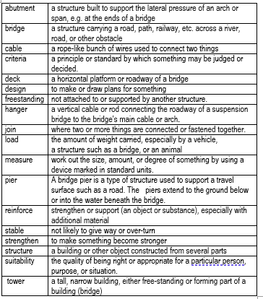

**3. Diagram/ picture/ quotation:**

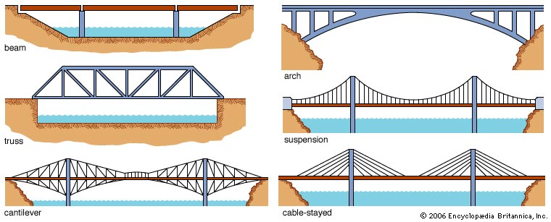

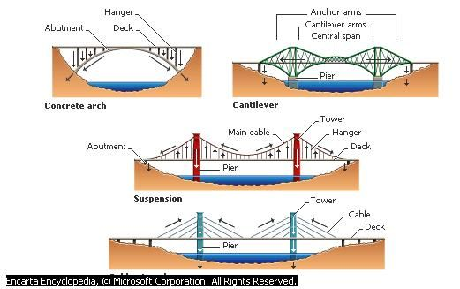

Cable Stayed Bridge

**2. What I am going to learn:**

**Who was Isambard Kingdom Brunel and why is he famous?**

He lived around 200 years ago, during the Victorian Age. He was born in Portsmouth on 9th Ap 1806.

He was a famous engineer whose designs changed the lives of many people.

We still use some of the bridges and railway stations built by Brunel.

**Brunel was the chief engineer of the Great Western railway, and he designed the railway line between London and Bristol. He also designed the Temple Meads station in Bristol, and Paddington station in London.**

He designed /engineered the ‘Clifton Suspension Bridge’.

In his lifetime he helped people travel further and quicker than before.

**5. Resources and skills to help me learn:**

Can you find a picture of Isambard Kingdom Brunel?

Use found materials to make your own model bridge at home.

Do you think bridges will be different in the future?

**Can you make a model bridge?**

**At the end of this unit you will:**

Design a model bridge that fits a given design criteria.

Use a range of appropriate tools, materials, and techniques to create a model bridge.

Experiment with and use different techniques to ensure your bridge is stable and strong.

Evaluate your bridge against the given design criteria.

1. **What I should already know:** From Y2

To make sensible choices as to which materials to use for their constructions. To measure materials to use in a model / structure.

To join things (materials/components) together in different ways.

To consider how to improve their construction.