|  |  |  |
| --- | --- | --- |
| **Year: 3** | **Subject: ENGLISH** | **Topic: Poetry** |

**Saint Elizabeth’s Knowledge Mat**



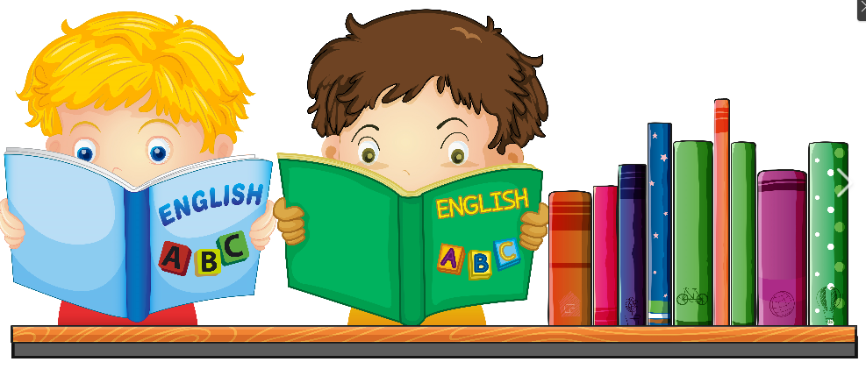

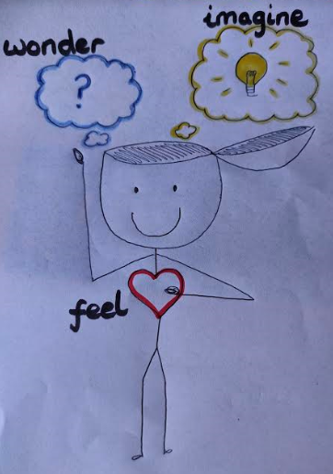

What do the words make me:

FEEL?

WONDER?

IMAGINE?

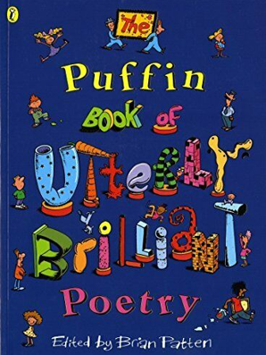

**5. Resources and skills to help me learn:** Practise reading poems aloud with your family! You could film yourself on a phone or tablet

and look at what you do well, then ask someone how they think you can improve your perfomance!

[**https://performapoem.lgfl.org.uk/**](https://performapoem.lgfl.org.uk/) **,** [**https://poetryroundabout.com/**](https://poetryroundabout.com/) **, The Puffin Book of Utterly Brilliant Poetry**

**3. Diagram / picture / quotation:**

**4. Important vocabulary and facts:**

**Poem** – imaginative writing with a pattern.

**Line** – an idea**.**

**Verse** – a group of ideas.

**Rhyme** – words that sound similar (eg. phone, bone, roam).

**Repetition** – the same word or words used again and again and again!

**Alliteration** – the same SOUND at the BEGINNING of words, (eg Fred’s phone fell).

**Onomatopoeia** – a word that sounds like the sound it is describing (eg pop, drip, fizz).

**2. What I am going to learn:**

-Poets choose words to make the reader FEEL, WONDER & IMAGINE.

-A line in a poem is a short idea, we start a new line for a new idea.

-A poem is split into verses. Each verse usually has the same number of lines and may follow the same pattern.

-I will write a poem by **thoughtfully choosing words to make my reader feel, wonder and imagine**. I will organise my ideas into lines and **verses** that follow a pattern.

1. **What I should already know:**

-A poem is a short, descriptive piece of writing that follows a pattern.

-Some poems rhyme, but not all.

-I have read and performed poems with my class.

-I have chosen interesting words to write my own poem, with some help from my teacher.