Year: 3 | Subject: ENGLISH | Topic: Information text (‘non-chronological report’)
Saint Elizabeth’s Knowledge Mat

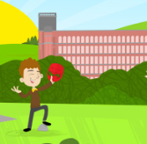
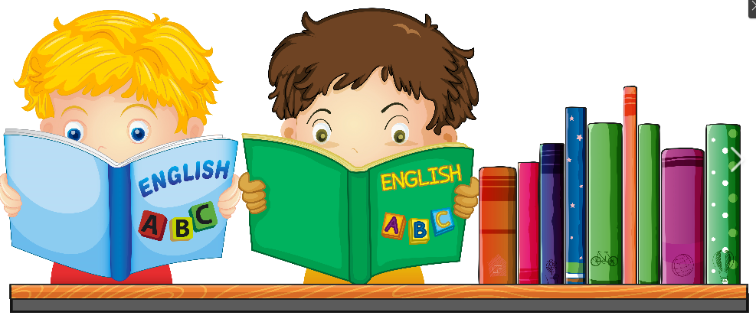
2. What I am going to learn:
-I will start my writing with an introduction paragraph and end my writing with a conclusion paragraph (following the same pattern I used to write the introduction and conclusion in my instruction texts).

- I will use sub-headings to organise my writing (like I did when writing an instruction text).
- I will collect facts about my subject and organise these facts into groups (eg ‘Food’, ‘Houses’, ‘People’) and these groups will become my sub-headings.
- I will order my facts; make the facts into full sentences; finally link the facts together, using words such as ‘Furthermore… Did you know that… Historians tell us that…’.
-I will practise using adverbials at the start of a sentence.
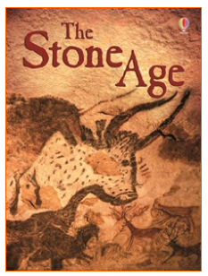
4. Important vocabulary and facts:
Paragraph – a group of sentences about the same thing.
Introduction – the very first paragraph that tells the reader what the writing is going to be about.
Conclusion – the very last paragraph that reminds the reader what they have learnt.
Subheading / subtitle – a title for a part of the writing.
Non-chronological order – main paragraphs can be read in any order.
Adverbial – words that tell you WHEN, WHERE or HOW something is done.
Fronted adverbial – an adverbial at the start of the sentence.
Comma – follows a fronted adverbial
- What I should already know:
-Information texts teach us about a topic.

-Information texts usually have written information and pictures to help us understand the topic.

-I have written about factual events and things I know about.

5. Resources and skills to help me learn:
Collect facts about something that interests you.
Can you write about your subject using our
boxing up grid to support you?

There are lots of incredible information books at
the library. I love Usbourne book, like the book
shown here:

3. Diagram / picture / quotation:

How to write an INTRODUCTION:
Do you know_______________ ? Let me tell you _____________ ! Read on to ________________ …

How to write a CONCLUSION:
Now you know all about _____ . I suggest you ________ .

