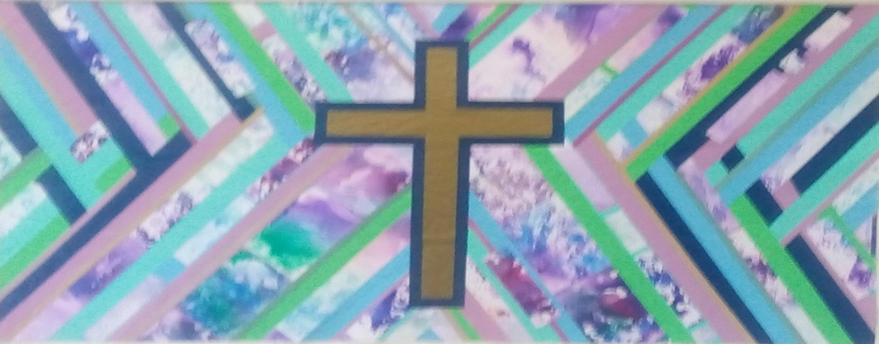
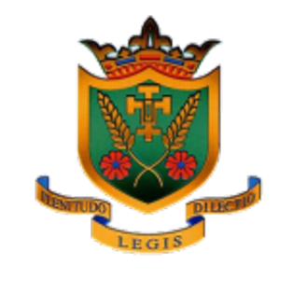
Welcome Back
Walsingham Class News
Welcome back to school! We hope that you have had a fun-filled summer holiday and that you’re ready for some exciting and challenging learning in Year Three! Our last school year was very strange for everybody and we’re looking forward to having you all back in school. Our priority will be ensuring that everyone feels happy and safe in school.
Mrs Parry will be teaching the class all day on a Monday, Tuesday and Wednesday. Mrs Lawler will be teaching on a Thursday and Friday. Mrs Plastow is our excellent class Teaching Assistant!
Franciscan Values
As a school, we have been thinking about our Franciscan heritage and have decided to introduce seven values – based on the Franciscan values – to underpin all that we do at St Elizabeth’s. The seven values are: Joy, Forgiveness, Faith, Respect, Service, Peace and Stewardship. We will all strive to live out these values on a daily basis but each class will pay close attention to their own value. In Year 3, our value is respect. We have explained ‘respect’ as treating others as we wish to be treated. We have already looked at the bible story ‘The Good Samaritan’ as an example of this.
Come and See
Our first topic in RE this term is ‘Homes and Family’. In this topic, we will explore: ‘What makes a house a home?’ We will be learning about how God wants us to treat our family with love, kindness and respect. Please have a look on the class webpage on the school website for all current RE ‘Knowledge Organisers’, which will inform and guide you to support your child’s learning in RE.
Our second topic this term is ‘Promises’. In this topic, we will explore how belonging to a group involves promises and expectations. We will be learning about the meaning of the promises made at Baptism.

Advent Term 2021
The final topic in this term will be ‘Visitors’. Pupils will explore the demands and joys of visitors and know and understand that Advent is waiting for the coming of Jesus.
Prayer and worship remain an integral part of each day and the children are very welcome to bring in and share any prayers or books on our class prayer table.
English
Last year, as part of our Recovery Curriculum, we included spellings that the children practised during the infants, as well as spellings from our Year 3 list. This worked well and we will continue to include them on the children’s weekly spellings this year too.
We will be teaching whole class ’Talk for Reading’ every day where children experience high quality extracts of texts from a range of genres each week. As well as whole-class ‘Talk for Reading’ sessions, the children will be in a guided reading group and will read with/practise reading skills with the class teacher once a week. In both these sessions, we will (throughout the year) focus on one of the nine reading domains in order to develop skills in each area. The readings domains are: retrieval, inference and justification, explanation, vocabulary, summarising, prediction and justification, organisation and presentation, effects of word choice, comparison. Of course, the children will have the fabulous ‘My Book Blog’ books (both home and class readers) to enjoy. Mrs. Lawler and Mrs. Plastow will be monitoring the childrens progress through this.
In Writing, we will be using Pie Corbett’s ‘Talk 4 Writing’ approach to learn a text and eventually write our own! In the first half of the term, we will be writing a poem based on Kit Wright’s ‘Magic Box’ (this topic will require the children to develop their creative vocabulary). Furthermore, we will be writing a set of instructions (this topic will require the children to focus on sentence structure). Writing lessons begin with 10 minutes of grammar or spelling practise.
Mathematics
Reading at Home
My Book Blog: Towards the end of Year Two this was introduced to some of the children. We will be using this now as our home reading scheme.
Children are still expected to read at home for 10 minutes every day (this includes reading to an adult) and the more often they read the better! Additionally, it is essential that they complete all the related activities on the book blog website to progress to the next book/ level - we’d appreciate your continued support with these tasks. If your child has struggled to read any words, we suggest recording up to five words on a bookmark / other and to revisit these until secure.

P.E. Kit
The children will have two P.E. lessons each week. This term they will be on Tuesday and Wednesday afternoons. We are lucky to have external coaches for both these sessions. Lessons will be outside for the foreseeable future so please make sure that your child comes to school in their Winter outdoor P.E. kit. This should be: plain dark tracksuit bottoms, yellow polo shirt and yellow (school) sweatshirt and outdoor trainers. Don’t forget a coat too, we will go out in all weathers!

Water Bottles and snacks
Children are asked to bring a water bottle to school each day. They are encouraged to drink water throughout the day to aid concentration. Water bottles should be taken home each night for washing. Healthy snacks (fruit or vegetables) are needed for break times to keep the children going until lunch or the end of the day!

Watches
We encourage the children to wear an analogue watch (a watch with a face and hands) to school, to help them learn to tell the time.

Extra!
Our classroom coat pegs are rather cramped – a smaller bag is best!
Following Covid advice we ask children not to bring additional stationary into school. We also need to mention that if children wish to bring a small pocket-sized toy to play with at playtimes, these must not be shared with other children.

As a school, we will be using Power Maths for the teaching of Mathematics this year. Our textbook for the Autumn (Advent) term is called Power Maths Year 3, Textbook 3A.
During this term, we will cover a units about Place Value within 1000, a second unit about Addition and Subtraction followed by Multiplication and Division (1).
We will revise the 10, 2 & 5 x and other Learn It’s from Y2 initially. Check out the MyMaths website (username: stelizabeths - password: circle). We will add work to this site termly. Look out for the relaunch of Times Table Rock Stars coming soon!
Science
In Science, our first topic for this term is PLANTS. Our learning will include: Identifying the parts of a flowering plant; describing what plants need to grow well and conducting a fair test to prove this; investigating how water travels in plants; explaining pollination and fertilisation in a flowering plant; describing the different methods of seed dispersal.
Geography
During this first half term, we will be discovering more about maps and mapping - exploring the hemispheres, lines of longitude and latitude of the world + grid references.
Art
In Art, the children will be exploring the art of ‘Joseph Wright of Derby’. You can visit Derby Museum and Art Gallery to see his famous painting ‘A Philosopher giving that Lecture on the Orrery in which a lamp is put in place of the Sun’.
Computing
We will be using Purple Mash to learn Coding.
Music
In music this term, we will be following the ‘Charanga’ Scheme. Learning the recorder will depend upon Covid guidelines.
Twitter
Please follow us on our new class Twitter account: @walsingham2021
General Information
Reminders
Monday
Tuesday | P.E with external coach and Mrs. Parry
Wednesday | Spelling Test  New spellings sent home to learn  P.E. with external coach
Thursday
Friday | Homework may be set
If you have any quick questions, please feel welcome to send them to us via our class email and we’ll endeavour to get back to you as soon as possible. However, please note that we only check the email at the very end of the school day, so any urgent communication is best done through a handwritten note handed in to us at the start of the school day and or a message via the school office (01773 822278). We are really looking forward to an exciting term and a fun-filled year.
Mrs. D. Parry, Mrs. H. Lawler and Mrs. L. Plastow.

